Chapter Three

System Analysis and Design

* 1. Introduction

Water quality monitoring is a critical concern in aquaculture and environmental engineering, especially in freshwater ecosystems where fish farming activities generate substantial amounts of nitrogenous waste. Among these pollutants, ammonia (NH₃) stands out due to its toxicity and capacity to disrupt aquatic life, particularly when concentrations exceed tolerable thresholds. The inability to detect such contamination promptly and affordably in many rural and peri-urban Nigerian communities has contributed to ecological degradation and diminished fish productivity. The development of intelligent sensing technologies, particularly those integrated with Internet of Things (IoT) architectures, offers promising avenues for real-time detection and reporting. However, the high cost of industrial-grade sensors—such as the Manning EC-FX-NH₃—and the complexity of deploying hardware in remote environments pose significant challenges to full-scale implementation. As a result, simulation emerges as an effective alternative for both prototyping and research validation. This study proposes a simulation-based model of a single ammonia sensor system using the specifications of the Manning EC-FX-NH₃. The system is designed to replicate sensor behavior, perform virtual signal processing, transmit data over a networked protocol (WiFi via TCP/IP), and visualize readings in a custom-built desktop application. The project focuses on:

* Emulating the sensor's analog output using synthetic data generators,
* Designing a digital circuit model and embedded firmware logic,
* Constructing a GUI-based dashboard for real-time feedback, and
* Validating system response through simulation of ammonia spikes and safe ranges.

The subsequent sections in this chapter detail the environmental and computing problems motivating this work, assess current monitoring practices and their limitations, outline functional and non-functional system requirements, and present both the logical and physical design of the simulated platform. Together, these components form the architectural blueprint for a smart, scalable, and research-ready ammonia detection system that addresses local water contamination challenges through digital simulation.

3.1.1 Research Design Overview

This study adopts a simulation-based design methodology to model the behavior of a digitally integrated ammonia monitoring system for freshwater aquaculture. Instead of deploying physical hardware, the project emulates sensor output, communication protocols, and user interface logic using virtual modules and synthetic data streams. The design incorporates four core components: a simulated RS-485 sensor engine based on the Apure NHN-206 specifications, embedded microcontroller logic mimicking ESP32 operations, WiFi-based TCP/IP transmission routines, and a Python-based graphical dashboard. This approach enables rigorous testing of data flow, threshold detection, and system responsiveness while maintaining affordability and adaptability. The simulation serves as a proof of concept and pedagogical prototype for digital environmental sensing in low-resource contexts.

3.2 Problem Analysis

Despite the ecological importance of water quality monitoring in aquaculture systems, existing practices remain fundamentally analog, fragmented, and reactive. The central challenge addressed in this project is the absence of digital integration across the sensing, transmission, and visualization domains of ammonia detection in freshwater bodies. This technological void impairs the ability of fish farmers and environmental agencies to respond proactively to contamination risks—especially in resource-constrained settings. Ammonia (NH₃), a critical parameter in aquaculture monitoring, is traditionally assessed through:

* Manual sampling and chemical reagent kits,
* Laboratory-based assays requiring logistical coordination,
* Handheld meters lacking network connectivity or real-time data logging.

These methods offer isolated point-in-time readings but fail to provide continuity, accessibility, or remote responsiveness. The absence of digitally integrated systems means:

* No automated sensor-to-dashboard communication,
* No real-time alert generation based on threshold analysis,
* No long-term data storage for trend forecasting or policy feedback,
* No modular software architecture to scale across communities.

Commercial sensors such as the Manning EC-FX-NH₃ offer high-quality readings, but are constrained by cost, deployment complexity, and limited interface compatibility. As such, physical implementation remains out of reach for many local institutions, informal farms, or academic field studies. This project directly responds to the lack of digital integration by proposing a simulation-driven architecture that emulates the full pipeline of an intelligent ammonia sensing platform. By virtualizing:

* The sensor’s analog output,
* Embedded microcontroller processing,
* WiFi-based data transmission,
* And desktop GUI visualization,

The system demonstrates how digital integration can be achieved affordably and pedagogically, even in the absence of physical hardware. This strategic pivot positions the project not only as a research prototype, but as a blueprint for scalable, intelligent environmental monitoring.

3.3 Analysis of the Existing System

Water quality monitoring in fish farming contexts remains predominantly analog, fragmented, and reactive. In particular, the detection of ammonia—a key parameter linked to aquatic toxicity—is still conducted using techniques that lack digital integration, autonomous functionality, and real-time responsiveness.

1. Manual Methods and Chemical Kits

Most fish farmers rely on periodic testing using chemical reagent kits. These methods involve manual sampling and visual interpretation of colorimetric changes, often subject to human error and environmental interference. The process is episodic, lacking temporal continuity or electronic logging, and does not support automated alerts or predictive analytics.

1. Laboratory-Based Assays

Where infrastructure permits, water samples are sent to laboratories for ammonia concentration analysis. Although these techniques are scientifically valid, they are slow, costly, and spatially disconnected from the monitoring environment. More critically, they do not provide dynamic feedback or interface with decision-support tools. This latency undermines timely intervention in cases of rising toxicity.

1. Commercial Handheld Sensors

Portable meters, such as ammonia-specific probes, offer direct readings but typically operate as closed-loop systems with no networking capabilities. They lack built-in microcontrollers, wireless transmission modules, or software interfaces, rendering them unsuitable for scalable deployment or remote environmental management.

Table 1.0: Technical Shortcomings of the Existing System

| Dimension | Deficiency |
| --- | --- |
| Connectivity | No support for WiFi, GSM, or serial data output |
| Automation | Requires human intervention; no autonomous sensing or alerting |
| Data Archiving | No electronic storage; readings are transient and manually recorded |
| Visualization | Absence of GUI dashboards or real-time graphical interfaces |
| Scalability | Unsuitable for multi-node deployments across farming clusters |
| Integration | Incompatible with IoT ecosystems, cloud platforms, or embedded logic |

These limitations reveal a profound gap in digital integration, where environmental sensing technologies remain disconnected from the computational frameworks required for intelligent water management. The current system is not designed to operate as a cyber-physical system, nor does it support embedded intelligence, continuous monitoring, or user-centered interface design. The proposed project addresses these deficits by simulating the behavior of a fully integrated ammonia sensing system. Using synthetic data streams, embedded logic emulation, TCP/IP communication protocols, and custom-built dashboard interfaces, the simulation acts as a digitally cohesive prototype—paving the way for affordable, scalable, and responsive water monitoring systems in aquaculture.

3.4 System Requirements Analysis

The successful design and simulation of a digitally integrated ammonia monitoring system requires a clear specification of both functional and non-functional requirements. Functional requirements define the essential operations of the system, while non-functional requirements characterize its operational constraints and performance expectations. These specifications form the cornerstone of the design process and ensure that the simulated platform fulfills its intended academic and environmental objectives.

3.4.1 Functional Requirements

The functional scope of the system encompasses sensor emulation, embedded logic simulation, data communication, and graphical visualization. Specifically, the system shall:

* Emulate Ammonia Sensor Output Generate synthetic analog readings to replicate the behavior of the Manning EC-FX-NH₃ sensor across variable concentration ranges (e.g., 0–100 ppm), including realistic noise and fluctuation patterns.
* Implement Virtual Embedded Logic Simulate the operational flow of a microcontroller (e.g., ESP32), including data acquisition, filtering, and threshold evaluation, using algorithmic rules or pseudo-code frameworks.
* Transmit Data via Simulated Network Utilize TCP/IP protocols to virtually transmit readings from the simulated sensor system to the host desktop application in real time.
* Visualize Readings on Desktop GUI Display ammonia concentration dynamically using a Python-based graphical interface, featuring numeric indicators, time-series graphs, and color-coded alerts based on safety thresholds.
* Trigger Alerts Based on Thresholds Notify the user when simulated ammonia levels exceed a predefined limit (e.g., 30 ppm), using visual markers (e.g., red indicators) or popup notifications.
* Log and Export Data Streams Record simulated readings locally and offer export functionality (e.g., CSV format) for archival or analytical purposes.
* Support Testing for Varying Input Conditions Allow for manual or automated adjustment of synthetic input variables to test system behavior under high, low, and unstable ammonia conditions.

3.4.2 Non-Functional Requirements

The system’s non-functional requirements define the quality attributes necessary for reliable simulation, user accessibility, and research reproducibility. These include:

* Accuracy of simulation-generated data must reflect plausible ammonia concentration patterns, maintaining temporal consistency and scientific relevance for water quality analysis.
* Low Resource Utilization The simulation engine and dashboard must operate efficiently on standard academic desktop systems without requiring specialized hardware or excessive computational resources.
* Cross-Platform Compatibility Designed to function on common operating systems (e.g., Windows, Linux), using portable libraries and dependencies.
* Scalability and Modularity Architected for future enhancements, including integration with real sensors, cloud databases, or additional environmental parameters.
* Security of Data Transmission Simulated communication shall include error checking, packet integrity validation, and optional encryption protocols to mimic secure networking principles.
* User-Centric Interface Design The dashboard GUI should be intuitive, minimizing cognitive load and requiring minimal technical training for effective usage.
* Maintainability The system should include clear documentation, modular code architecture, and testable units to facilitate debugging, replication, and future academic use.

This requirement analysis ensures that the proposed simulation not only mirrors the behavior of a physical ammonia sensor system but also adheres to the principles of software engineering and environmental computing. It supports a research-friendly framework capable of demonstrating digital integration in environmental monitoring, even in the absence of physical equipment.

3.5 System Design

3.5.1 Logical Design

The logical design of the proposed simulation-based ammonia monitoring system defines the computational architecture, data processing workflow, and interaction logic among its core components. Although virtual, the system replicates the behavior of a physical sensor network and adheres to principles found in embedded system engineering, environmental computing, and software architecture.

System Workflow Overview

The system architecture emulates four primary modules:

1. Simulated Sensor Module This module generates synthetic ammonia concentration data based on a statistical model designed to reflect real-world aquatic fluctuations. The virtual sensor mimics the behavior of the Manning EC-FX-NH₃ by producing readings in parts per million (ppm) across a configurable time interval.
2. Embedded Logic Module Representing the microcontroller (ESP32), this module processes incoming sensor data using conditional logic and control flow structures. It performs:
   * Threshold Evaluation: Detects when ammonia levels exceed critical limits (e.g., 30 ppm).
   * Data Packet Formatting: Encodes readings into structured messages for transmission.
   * Trigger Control: Activates alert sequences when dangerous levels are observed.
3. Communication Protocol Module Utilizing TCP/IP, the system emulates wireless data transfer from the sensor unit to a receiver (desktop interface). This module ensures packet integrity, handles data routing, and simulates latency conditions to validate transmission robustness.
4. Dashboard Visualization Module A Python-based GUI receives and renders sensor readings in real time. Key functionalities include:
   * Live Graphs: Ammonia concentration plotted over time.
   * Indicator Panels: Numerical values and alert colors.
   * Threshold Alerts: Popup or color-coded warnings when values exceed safe ranges.
   * Data Logging: Archiving readings for trend analysis and research documentation.

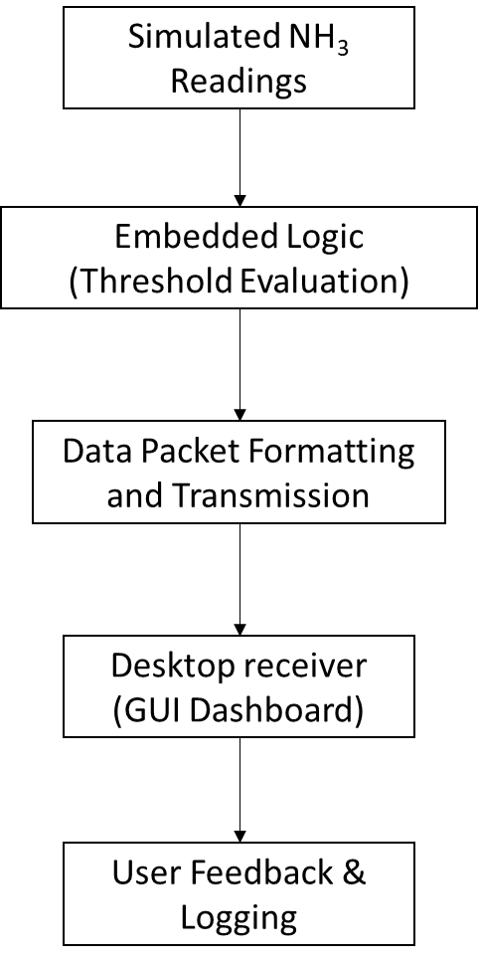

Figure 1.0: Logical Flow Diagram

This virtual architecture replicates the key behaviors of a real-world cyber-physical ammonia sensing system, offering an academic and research-valid prototype. It supports system validation, interface testing, and digital integration analysis, without requiring hardware deployment.

3.5.2 Physical Design

Although the architecture presented in this project is fundamentally simulated, its physical design is structured to reflect the real-world deployment of an intelligent, submersible ammonia monitoring system using the Apure NHN-206 sensor. This revised model discards the previously considered Manning EC-FX-NH₃—whose gas-phase detection limitations made it unsuitable for aquatic applications—and pivots toward a more contextually appropriate probe that detects ammonium ions (NH₄⁺) directly within freshwater environments. At the core of the physical system is the Apure NHN-206, a PVC membrane ion-selective electrode (ISE) probe that supports RS-485 Modbus RTU communication, embedded temperature compensation, and full IP68 waterproofing, making it ideal for direct submersion in ponds, tanks, and similar settings. Its ¾" NPT mounting thread enables secure installation, while its Modbus interface facilitates seamless data exchange with embedded controllers.

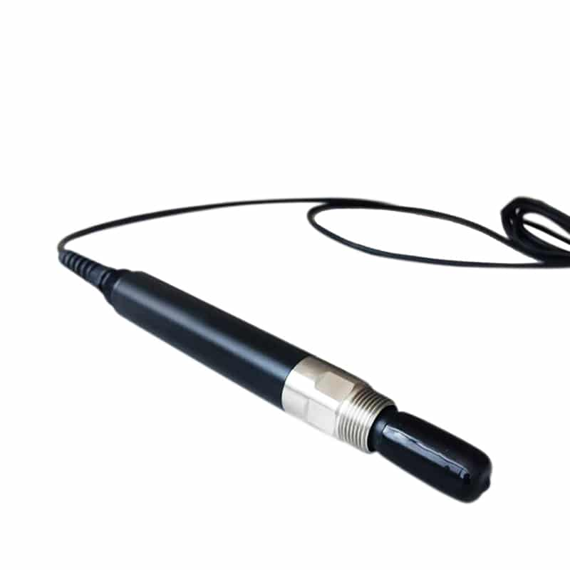

Figure 2.0: NHN Online Ammonia Nitrogen Sensor – Apure (apureinstruments, 2025)

The sensor’s digital output is interfaced via a TTL-to-RS485 converter module, which translates Modbus signals for compatibility with the ESP32 microcontroller. This controller simulates register polling, processes the received data, and transmits ammonia readings wirelessly using TCP/IP protocols over WiFi. On the receiving end, a desktop application built in Python acts as the graphical interface for real-time monitoring. It interprets the transmitted values, displays readings numerically and graphically, and issues alerts when concentrations exceed predetermined safety thresholds. The dashboard also supports logging and export functionality for downstream analysis.

The following configuration represents the simulated physical setup:

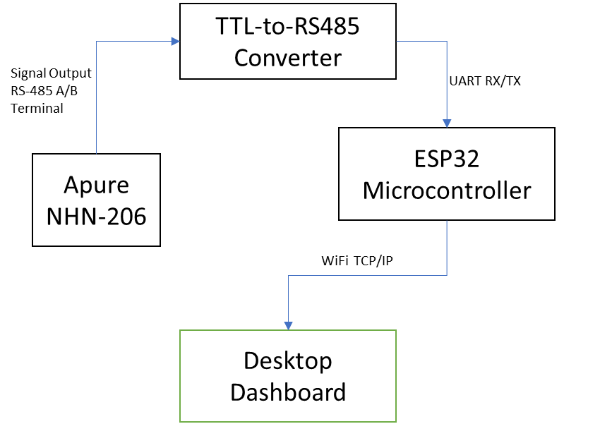

Figure 3.0: Simulated Architecture of Submerged Ammonia Sensor System

Figure 3.0 illustrates the digital integration flow of the simulated water quality monitoring system centered around the Apure NHN-206. The sensor’s RS-485 Modbus RTU output connects to a TTL-to-RS485 converter, which serves as the signal bridge into the ESP32 microcontroller’s UART interface. The ESP32 processes incoming data using virtual Modbus polling logic, encodes the readings, and transmits them wirelessly using TCP/IP protocols. A Python-based desktop dashboard receives the packets in real time, parses NH₄⁺ concentration levels, and displays them graphically along with threshold alerts. This configuration replicates the behavior of a field-deployable ammonia monitoring platform while remaining entirely virtual—enabling simulation-based testing of sensing logic, communication reliability, and user interface responsiveness without physical deployment. In a real deployment scenario, the system would be housed within a waterproof, UV-resistant enclosure, with protective cable shielding and voltage regulation hardware. The sensor lead would extend into the water body to ensure direct ion contact, while the ESP32 and converter modules would be mounted above the waterline with appropriate moisture barriers. Although this physical design remains virtual in implementation, it closely mirrors field-ready environmental monitoring systems. It serves as a blueprint for low-cost, scalable deployment and offers a pedagogically valid foundation for understanding cyber-physical integration in aquatic sensor networks.

3.5.2.1 TTL-to-RS485 Converter Configuration

To facilitate communication between the Apure NHN-206 sensor and the ESP32 microcontroller, a TTL-to-RS485 converter is employed. This module acts as a protocol bridge, translating differential RS-485 signals into UART-compatible TTL logic levels that the ESP32 can interpret.

Functional Role

* RS-485 Terminals (A/B): Receive Modbus RTU signals from the sensor
* TTL UART Pins (TX/RX): Interface with ESP32’s UART port
* Direction Control (DE/RE): Managed via a digital GPIO pin on ESP32 to toggle between transmit and receive modes

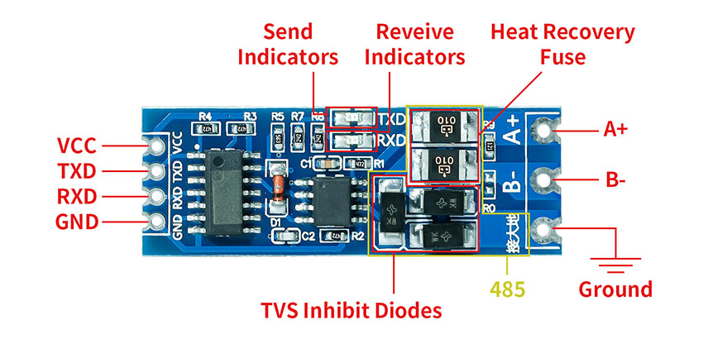

Figure 4.0 : Hardware Layout of TTL-to-RS485 Converter Module (Elecrow, 2025)

The diagram above presents a labeled view of a TTL-to-RS485 communication interface module used to bridge differential Modbus signals from the Apure NHN-206 sensor with the UART-based ESP32 microcontroller. The module includes key terminals for power, signal transmission, protection, and line-level indication:

* VCC and GND: Serve as the power input terminals, typically receiving 3.3V or 5V DC from the ESP32.
* TXD and RXD: Transmit and receive TTL logic signals to and from the ESP32 UART pins.
* A+ and B- (RS-485 Terminals): Interface directly with the RS-485 A/B signal lines from the sensor, supporting bidirectional Modbus RTU communication.
* Signal Indicators: LED indicators provide visual feedback for data transmission (“Send”) and data reception (“Receive”), facilitating debugging and status monitoring.
* TVS (Transient Voltage Suppression) Diodes: Protect the converter and downstream microcontroller from voltage spikes and electrostatic discharge.
* Heat Recovery Fuse: Offers thermal protection against excessive current or overheating conditions, enhancing device safety during prolonged operation.
* Ground Terminal: Maintains signal reference for RS-485 communication, ensuring data integrity across the differential line.

This converter module plays a critical role in translating the sensor’s electrical protocol into microcontroller-readable format, thus enabling accurate ammonia data acquisition, threshold evaluation, and networked transmission via ESP32.

3.5.2.2 ESP32 Microcontroller Configuration

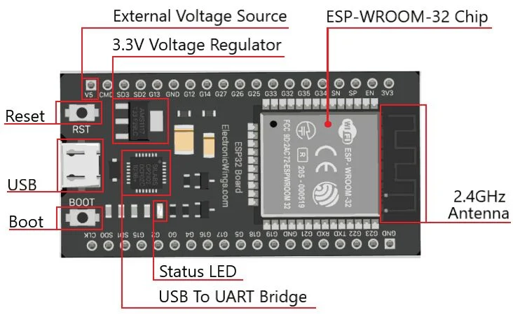

Figure 3.3: Labeled View of ESP32 Microcontroller (ESP-WROOM-32) – ([electronicwings](https://www.electronicwings.com/esp32/introduction-to-esp32), 2025)

The diagram presents a labeled layout of the ESP32 development board, specifically the ESP-WROOM-32 module, which serves as the central processing unit of the ammonia monitoring system. This microcontroller integrates dual-core processing, WiFi and Bluetooth connectivity, and a rich set of peripheral interfaces suitable for embedded environmental sensing.

Key labeled components include:

* Micro-USB Port: Used for power supply and firmware uploading via serial interface.
* Voltage Regulator (AMS1117): Converts USB 5V input to 3.3V required by the ESP32.
* UART Pins (TX/RX): Facilitate serial communication with external devices such as the TTL-to-RS485 converter.
* GPIO Pins: General-purpose input/output pins used for digital control, Modbus direction switching, and optional sensor interfacing.
* Boot and Enable Buttons: Used to reset the board or enter flashing mode during programming.
* Power LED Indicator: Confirms active power supply to the board.
* User LED (GPIO2): Can be programmed for status indication or alert signaling.
* WiFi Antenna: Embedded within the module for wireless TCP/IP communication with the desktop dashboard.

This microcontroller executes Modbus polling routines, evaluates ammonia thresholds, and transmits formatted data packets over WiFi. Its compact form factor and low power consumption make it ideal for both simulation and field deployment in aquaculture monitoring systems.

Table 2.0: Core Hardware Components (Simulated Representation)

| Component | Description |
| --- | --- |
| Ammonia Sensor | Apure NHN-206: a submersible PVC membrane ion-selective electrode (ISE) sensor designed to detect NH₄⁺ levels in water. Emulated via synthetic Modbus register models. |
| Microcontroller Unit | ESP32 development board: processes Modbus RTU signals via UART, performs threshold analysis, and transmits formatted readings over integrated WiFi. |
| Power Supply | Simulated 12–24 VDC power source representing external supply to sensor and ESP32; modeled as continuous input for stable operation. |
| Communication Module | TTL-to-RS485 converter interfaced with ESP32 UART port; bridges RS-485 digital signal from the sensor to the controller. |
| Desktop Host | General-purpose computer running dashboard software; receives streamed data via TCP/IP and logs readings for real-time and archival analysis. |
| User Interface Display | Python-based GUI application developed using Tkinter or PyQt; visualizes sensor data with numeric indicators, time-series plots, and alert flags. |

3.5.3 Environmental Deployment Assumptions

In a physical context, the sensor and microcontroller would be housed in waterproof, UV-resistant casing with secure wiring and thermal insulation. Sensor leads would extend into the water column, allowing direct NH₃ contact. The dashboard would operate from a remote location or on-site terminal with access to the local WiFi mesh. Though simulated, this configuration models the essential electrical and logical structure of a complete ammonia sensing system—serving as a pedagogical prototype and a foundation for future deployment.

3.6 Summary

This chapter has presented a comprehensive framework for simulating a digitally integrated ammonia monitoring system tailored to freshwater aquaculture environments. Recognizing the limitations of conventional analog and semi-digital techniques—particularly their inability to provide continuous sensing, automated threshold alerts, and remote visualization—the project introduces a fully virtual architecture that mirrors the operational behavior of a submerged, field-ready sensor network using accessible components. The analysis began with a critique of manual testing kits, laboratory assays, and isolated handheld meters, identifying their shortcomings in connectivity, automation, and long-term decision support. At the heart of this investigation is the need to overcome the absence of digital integration in water quality systems—a gap that impedes proactive environmental response, especially in low-resource settings. In response, the solution simulates the interaction of four core modules:

* A synthetic data engine reflecting the RS-485 Modbus output behavior of the Apure NHN-206 submerged ammonium sensor
* Embedded firmware logic emulating microcontroller-based signal parsing and threshold evaluation
* TCP/IP-based transmission protocols modeling wireless data exchange
* A desktop dashboard interface for live feedback, graphical representation, and archival logging

By articulating precise functional and non-functional requirements, the chapter ensures that the simulation meets academic standards for reproducibility and environmental relevance. The logical and physical design sections provide a blueprint for future integration with real sensor hardware—facilitating scalable research and sustainable water monitoring solutions across aquaculture contexts. Ultimately, the simulation functions as both a pedagogical tool and an engineering prototype, offering a credible alternative to costly sensor deployments while laying the groundwork for adaptive, community-driven environmental sensing systems.

.